Everyone must **prepare, understand, and explain the following topics in tomorrow morning session.**

Do not only read definitions — be ready to explain:

* What it is
* Why we use it
* How it works
* Real-world example / use case

## 1. Server Basics

Prepare:

* What is a Server?
A server is a powerful computer or software system that provides services, data, or resources to other computers (clients) over a network, usually running 24/7 to ensure availability. In simple terms, it’s the “provider” in the client–server model: clients request something (like a webpage or file), and the server delivers it.

* Client vs Server concept
The client–server concept is a network model where the client initiates requests (like opening a website in a browser), and the server responds by providing the requested data or service.

* Types of Servers:

* Web Server
* Database Server
* Application Server
* File Server
* Mail Server
* Game Server
* Proxy Server
* Virtual Server

Type | Purpose | Examples
Web Server | Hosts websites and delivers web pages | Apache, Nginx
Database Server | Stores and manages databases | MySQL, Oracle
File Server | Stores and shares files | Windows File Server
Mail Server | Sends, receives, and stores emails | Microsoft Exchange, Postfix
Game Server | Hosts multiplayer games | Steam servers
Application Server | Runs business applications | JBoss, WebLogic

## 2. Amazon EC2 Fundamentals

Prepare:

* What is Amazon EC2?
Elastic Compute Cloud (EC2) is a web service that provides resizable compute capacity in the cloud.
It allows you to launch virtual servers (instances) on demand, scale them up or down, and pay only for what you use.
Think of it as renting a computer in the cloud instead of buying physical hardware.

* What is an EC2 Instance?
An EC2 instance is essentially a virtual server running in Amazon’s cloud (AWS). Think of it as renting a computer in the cloud that you can configure, start, stop, and use just like a physical machine — but with far more flexibility.

* EC2 core concepts:

* Instance
* AMI
* Instance Type
* Security Group
* Key Pair
* Elastic IP
* EBS
* Pricing Models

Concept | Explanation | Example
Instance | A virtual server running on AWS | t2.micro (free tier)
AMI (Amazon Machine Image) | Pre-configured OS + software template | Amazon Linux 2, Ubuntu
Instance Types | Hardware configurations (CPU, memory, storage) | General Purpose, Compute Optimized
Elastic IP | Static public IP address for your instance | Useful for hosting websites
Security Groups | Virtual firewalls controlling inbound/outbound traffic | Allow SSH (port 22), HTTP (port 80)
Key Pairs | SSH keys for secure login | my-keypair.pem
EBS (Elastic Block Store) | Persistent storage volumes attached to instances | Like a virtual hard disk
Auto Scaling | Automatically adjusts number of instances based on demand | Scale up during traffic spikes
Load Balancer | Distributes traffic across multiple instances | Ensures high availability

## 3. EC2 Instance Families

Explain purpose + use cases of:

* General Purpose
* Compute Optimized
* Memory Optimized
* Storage Optimized
* Accelerated Computing

Family | Optimized For | Examples
General Purpose | Balanced CPU, memory, networking | t3, m5
Compute Optimized | High-performance processors for compute-heavy tasks | c5, c6g
Memory Optimized | Large memory for in-memory databases, analytics | r5, x1e, z1d
Storage Optimized | High disk throughput and IOPS for big data, NoSQL | i3, d2, h1
Accelerated Computing | GPUs or FPGAs for ML, AI, graphics | p3, g4, f1
High Performance Computing (HPC) | Specialized networking and CPU for scientific workloads | hpc6a, hpc7g

Also explain when to choose each.
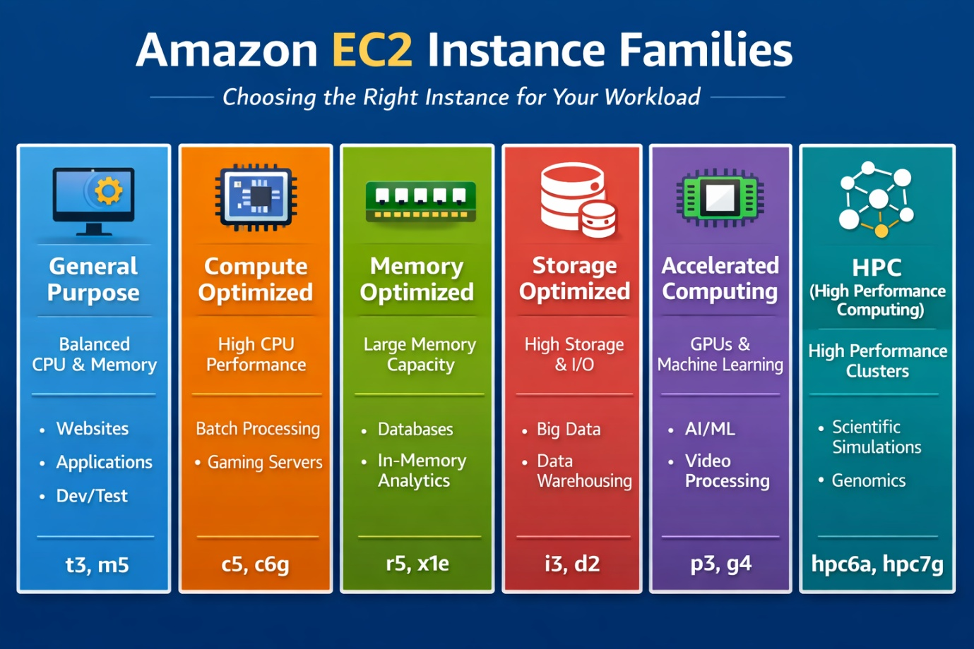

## 4. EC2 Security Concepts

Prepare detailed explanation for:

### Security Groups

* What is Security Group?
A Security Group in Amazon EC2 is a virtual firewall that controls inbound and outbound traffic to your instances. It acts at the instance level, not the subnet level, and defines which types of network connections are allowed or denied.

* Stateful behavior
* Inbound vs Outbound rules
* Rule examples

### Key Pairs

* Public key vs Private key
* PEM file purpose
* SSH authentication workflow
* Best practices

### IAM Roles

* What are IAM Roles?
* Why avoid hardcoded credentials?
* Temporary credentials concept
* Example use case

### VPC Isolation

* Public subnet
* Private subnet
* Why databases stay private

### Route Tables

* Purpose
* Internet Gateway
* NAT Gateway
* Routing examples

### NACLs

* Stateless behavior
* Allow vs Deny
* Security Group vs NACL comparison

## 5. Networking Essentials

Prepare:

### CIDR & Subnetting

* CIDR notation
* /16 vs /24
* Public vs Private subnet

### Inbound & Outbound Traffic

* Meaning
* Examples
* Best practices

## 6. User Data (Bootstrap Automation)

Explain:

* What is User Data?
* Why use it?
* How it works
* cloud-init role
* User data log locations
* Re-running user data
* Shell script vs Cloud-config

Also understand this example:

```bash
#!/bin/bash
sudo yum update -y
sudo yum install -y httpd
sudo systemctl start httpd
sudo systemctl enable httpd
```

## 7. AMI & Snapshot Deep Dive

Prepare:

### AMI

* What is AMI?
* Components of AMI
* Internal working
* AMI launch process

### Snapshot

* What is Snapshot?
* Incremental backup concept
* Internal AWS storage behavior

### AMI vs Snapshot

* Differences
* Use cases

### Deletion Behavior

Explain:

* Delete first snapshot
* Delete AMI snapshot
* Delete AMI only
* Delete AMI + snapshots

## 8. EC2 Access Methods

Explain all 4 methods:

* SSH Client
* EC2 Instance Connect
* Session Manager (SSM)
* EC2 Serial Console

Prepare comparison:

* Public IP requirement
* Key pair requirement
* Best use cases

## 9. Lost PEM Key Recovery

Prepare:

What happens if PEM key is lost?

Recovery methods:

* Attach volume to helper EC2
* EC2 Instance Connect
* Session Manager
* Auto Scaling method

Also explain:

**Why AWS cannot recover/download lost PEM key.**

## 10. EC2 Status Checks

Explain:

* System Status Check
* Instance Status Check
* ELB Health Check

Difference between:

* 2/2 checks passed
* 3/3 checks passed

Troubleshooting approach.

## 11. EC2 Pricing Models

Prepare:

* On-Demand
* Reserved
* Spot
* Savings Plans

Explain:

* Advantages
* Limitations
* Real-world usage

## 12. EC2 Tenancy

Prepare comparison:

* Shared Tenancy
* Dedicated Instance
* Dedicated Host

Explain:

* Isolation level
* Cost difference
* Compliance use cases
* BYOL concept

## 13. Hands-On Commands (CLI)

Be ready to explain:

```bash
aws ec2 run-instances
aws ec2 describe-instances
aws ec2 stop-instances
aws ec2 describe-key-pairs
aws sts get-caller-identity
```

Explain command purpose + output.

## 14. EC2 Key Pair Internal Working

Prepare:

* Private key structure (.pem)
* Public key structure (.pub)
* How AWS stores public key
* How new EC2 instances receive authorized_keys
* Region-specific behavior of key pairs

## 15. Optional Advanced Topics (Bonus)

Anyone can volunteer to explain:

* EC2 Auto Scaling Policies
* Placement Groups
* EC2 Image Builder
* Security Group Limits

### Session Expectation

Tomorrow everyone should be ready for:

:white_check_mark: Topic explanation
:white_check_mark: Concept clarity
:white_check_mark: Real-world examples
:white_check_mark: Follow-up questions

